1. **Section Agenda**:
   1. How to start Kafka.
2. Steps differ based on Oss and their versions.
3. 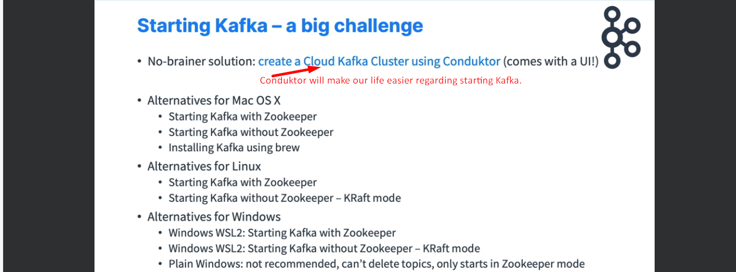
4. 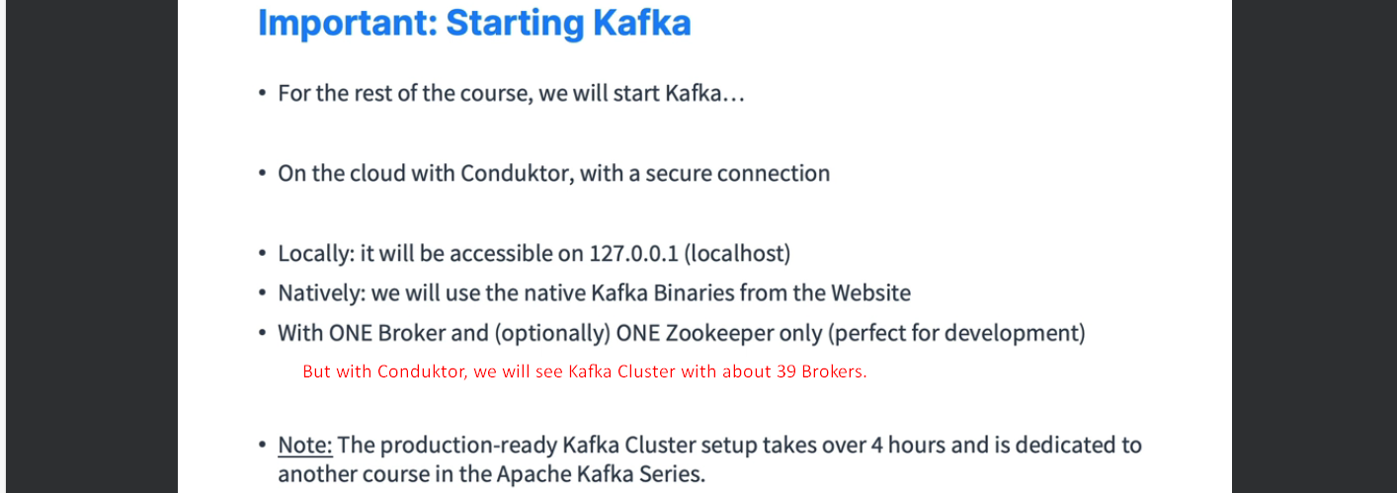
5. A diagram of a computer

   Description automatically generated  
   A close-up of a computer screen

   Description automatically generated  
   A diagram of a flowchart

   Description automatically generated A screenshot of a computer

   Description automatically generated